LP3 (BT) Mini Project

Guide: Prof. Amruta Aphale

Name: Manish Godbole (31226)

Kaustubh Joshi (31233)

Aditya Kadu (31234)  
Title: E-Voting System

Problem Statement:

Develop a Blockchain based application dApp for E-Voting System.

# Learning Objectives:

1. Understand the fundamental concepts of blockchain technology and its applications in secure voting systems.
2. Learn to design and implement a decentralized application (DApp) for e-voting using blockchain.
3. Develop skills in ensuring data integrity, privacy, and security within the voting process.
4. Explore user interface design principles to create an intuitive and user-friendly voting application.

# Learning Outcomes:

By the end of this project, participants will have:

1. Ability to design and implement a secure and decentralized e-voting application using blockchain technology.
2. Proficiency in applying cryptographic techniques to ensure data integrity and voter privacy.
3. Skills in creating an intuitive user interface that enhances user experience in the voting process.
4. Enhanced understanding of the challenges and solutions related to electronic voting systems, including scalability and security concerns.

# Theory:

**1. Overview of Blockchain Technology**

* Blockchain technology is a decentralized and distributed ledger system that securely records transactions across multiple computers. Each block in the blockchain contains a set of transactions and is linked to the previous block, forming a chain. This structure ensures that once a transaction is recorded, it cannot be altered or deleted, providing a high level of data integrity. The immutability of blockchain makes it an ideal foundation for applications requiring secure and transparent data management, such as e-voting systems.

**2. Importance of E-Voting Systems**

* E-voting systems aim to facilitate the voting process by allowing voters to cast their ballots electronically, increasing accessibility and efficiency. Traditional voting methods often face challenges such as long queues, human errors, and security risks related to tampering and fraud. By leveraging blockchain technology, e-voting systems can enhance security, ensure voter anonymity, and provide real-time auditing capabilities. This can lead to increased trust in the electoral process and higher voter participation.

**3. Components of an E-Voting System**

* An effective e-voting system comprises several key components:
* Voter Registration: A secure mechanism for registering voters and verifying their identities, often utilizing cryptographic techniques to ensure data privacy.
* Voting Interface: A user-friendly interface that allows voters to easily navigate the voting process, select candidates, and submit their votes.
* Blockchain Ledger: The underlying blockchain technology that records and stores votes in a secure, immutable manner, ensuring that all transactions are transparent and auditable.
* Vote Counting and Results: Automated processes to tally votes and provide accurate, real-time election results, leveraging the transparency and security of the blockchain.

**4. Security and Privacy Concerns**

* Security and privacy are paramount in e-voting systems. Implementing cryptographic techniques such as public-key infrastructure (PKI) ensures that votes are securely encrypted and can only be decrypted by authorized parties. Additionally, the use of smart contracts can automate and enforce rules related to the voting process, reducing the potential for fraud and manipulation. Maintaining voter anonymity while ensuring the integrity of the voting process is a significant challenge that must be addressed through thoughtful design and implementation.

**5. Challenges and Solutions**

* Despite the advantages of blockchain-based e-voting systems, several challenges remain, including scalability, accessibility, and regulatory compliance. Ensuring that the system can handle a high volume of transactions during peak voting times is critical for its success. Solutions such as sharding, off-chain transactions, and careful architectural design can help mitigate these issues. Additionally, engaging with stakeholders, including government bodies and electoral commissions, is essential to address legal and ethical considerations surrounding electronic voting.

# System Architecture:

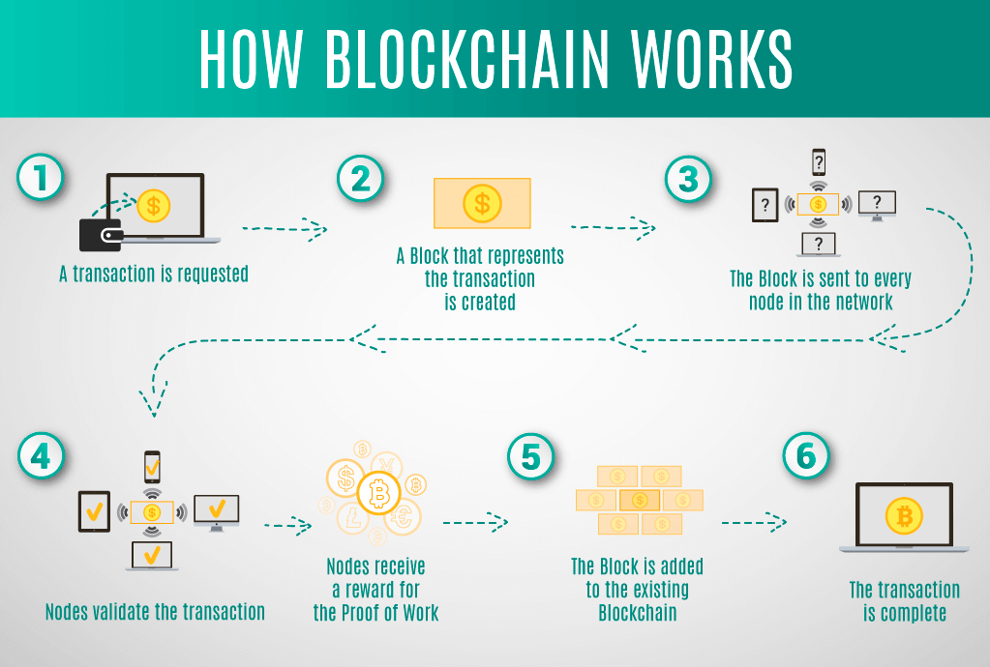

The system architecture for Blockchain Technology. Here's an overview of the system architecture:

**1. Voter Registration Module**

The voter registration module serves as the entry point for users to create and verify their accounts. Voters will provide necessary identification information, which will be securely hashed and stored on the blockchain. This ensures that personal data is protected while maintaining a record of registered voters.

**2. Voting Interface**

The voting interface provides a user-friendly platform for voters to cast their votes. It will display candidates and their respective information, allowing users to make informed decisions. The interface will also include security features, such as multi-factor authentication, to confirm the voter's identity before submission.

**3. Smart Contracts**

Smart contracts are deployed on the blockchain to facilitate and automate the voting process. These contracts define the rules of the election, including eligibility criteria, voting duration, and vote counting procedures. Once a vote is cast, the smart contract records it in the blockchain, ensuring immutability and transparency.

**4. Blockchain Network**

The blockchain network serves as the backbone of the e-voting system, providing a decentralized and tamper-proof ledger for all transactions. Each vote cast is recorded in a block, linked to the previous block, and secured through cryptographic hashing. This structure guarantees the integrity of the voting process, making it resistant to fraud and manipulation.

**5. Vote Counting Module**

Once the voting period ends, the vote counting module retrieves the data from the blockchain. It automatically counts the votes based on the smart contracts' defined rules, ensuring an accurate and transparent tally. The results can be verified through the blockchain's public ledger, allowing for independent audits.

**6. Results Announcement**

The results announcement component displays the final election results to stakeholders. It can be accessed through a web portal, ensuring transparency in the electoral process. This feature may also include detailed analytics, such as voter turnout and demographic information.

**7. Security Measures**

Security measures are implemented throughout the system to protect against unauthorized access and data breaches. This includes the use of encryption for data transmission, secure storage of voter information, and continuous monitoring of the system for potential threats. Regular security audits ensure that the system remains robust against evolving cyber threats.

**8. User Feedback and Support**

After the election, the system will provide a feedback mechanism for voters to share their experiences and report any issues encountered during the voting process. This feedback is essential for improving the system in future elections and ensuring a smooth user experience.

# Methodology/Algorithm Details:

# **1. Initialize Candidates**

# Define a structure for candidates that includes:

# ID: A unique identifier for each candidate.

# Name: The name of the candidate.

# Vote Count: A counter to keep track of the votes received by each candidate.

# **2. Voter Registration**

# Define a structure for voters that includes:

# Has Voted: A boolean to check if the voter has cast their vote.

# Vote: The ID of the candidate the voter has selected.

# Create a mapping to associate each voter’s address with their voter information.

# **3. Add Candidates**

# Implement a function to add candidates:

# Increment the candidate count.

# Store the candidate’s information in the candidates mapping.

# **4. Voting Process**

# Implement the voting function:

# Check if the voter has already voted using their address.

# Validate the candidate ID to ensure it corresponds to an existing candidate.

# Update the voter's status to indicate they have voted.

# Increment the selected candidate's vote count.

# **5. Emit Voting Event**

# After a successful vote, emit an event to notify that a vote has been cast. This helps in tracking voting actions on the blockchain.

# **6. Vote Counting**

# Implement a function to retrieve the total vote count for each candidate. This function can be called after the voting period ends to display the results.

# **7. Security Measures**

# Ensure proper checks are in place to prevent double voting and validate candidate selection.

# Utilize events to log actions and maintain transparency.

# **8. Result Announcement**

# After the voting concludes, compile the results and provide a function to view the total votes for each candidate. This can be displayed to users to confirm the outcome of the election.

# Results:

# 

# Analysis Conclusion:

The development of a blockchain-based E-Voting System demonstrates the potential of decentralized technology to enhance the electoral process. By leveraging the immutable and transparent nature of blockchain, this project addresses key challenges associated with traditional voting systems, such as security, fraud prevention, and voter accessibility.

The implementation of smart contracts allows for the automation of critical processes, including voter registration, vote casting, and tallying of results. This not only streamlines the voting process but also ensures that every vote is securely recorded and can be independently verified. The system's architecture promotes voter anonymity while maintaining data integrity, thereby fostering trust in the electoral process.

Furthermore, the design and user interface considerations taken into account enhance the overall user experience, making the voting process intuitive and straightforward for all participants. By incorporating security measures and thorough validation protocols, the system effectively mitigates risks associated with cyber threats and unauthorized access.

In summary, this E-Voting System exemplifies how blockchain technology can revolutionize the way elections are conducted. The insights gained from this project can serve as a foundation for further research and development, paving the way for more secure, transparent, and efficient electoral systems in the future.